**POSSIBLE QUESTIONS:**

**To be asked to the manufacturers:**

Key ones: Saint-Gobain, Norbord (although it is wood, now acquired by West Fraser Timber), Promat

* Who are their main clients? Their main competitors?
* (probably secondary) What is their target market?
* Tests performed
* Fire retardant certificates and tests done by competition
* Certificates in general, e.g. this one by Norbord

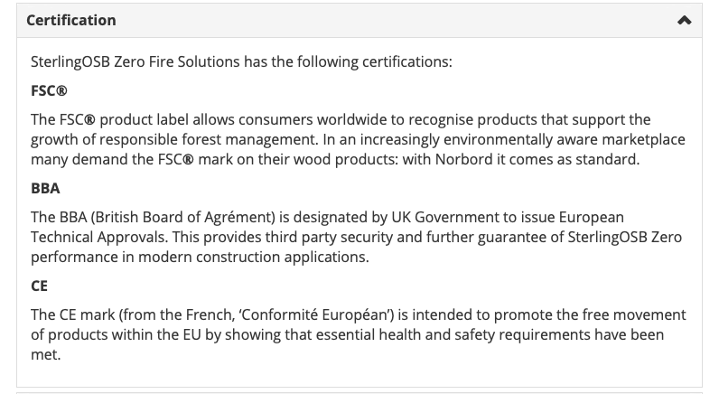

* Environmental pollution as a consequence of fire (remember case of formaldehyde for wood OSB)
* Dimensional change of panels as a consequence of panel moisture content, temperature, etc...
* **Bulk prices, how do they decide the bulking price?**
* (More secondary): DOPs, as for example

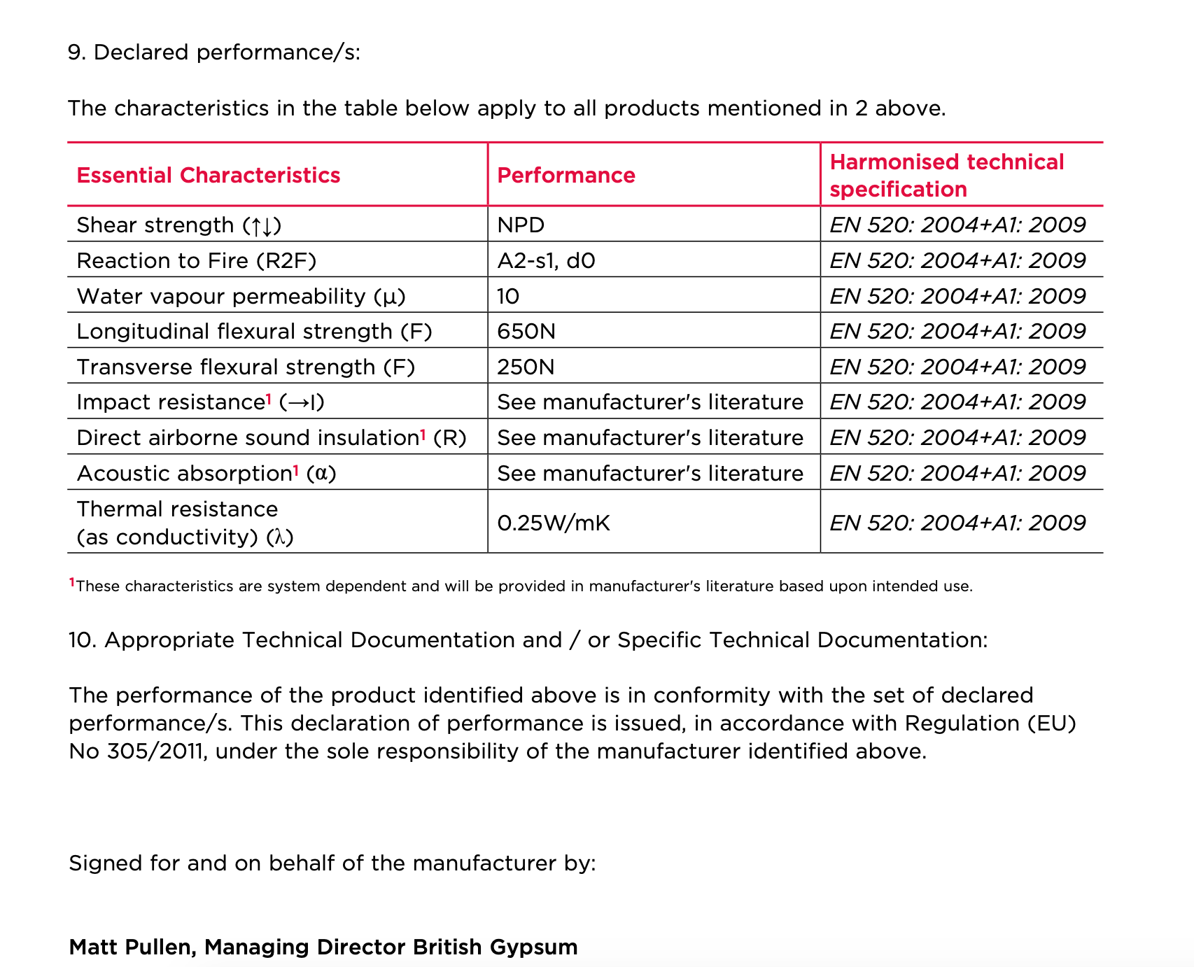

* (More secondary): plans for sustainability. Seems Saint-Gobain, Norbord are moving quite fast. Saint-Gobain has incentives, under the green home grant solutions.
* How ecologically friendly are gypsum based materials? Cement ones?
* What about wood stuff?

**To be asked to buyers:**

* What types of flat boards are you buying and why?
* Why are you buying this specific flat board?
* Which characteristics do you look for in flame-retardant flat boards?
* What are the three key things for you? (Highlight the flame-retardant aspect)
* Would you pay a premium for one of these properties?
  + Environmentally friendly?
  + Relatively lower toxicity?
* Are you aware of the gypsum-board flame retardant chemicals?
* Does your client, if any, care about which materials, or just the cost (quantity surveyors [Soben UK for commercial + Potter Raper also on instagram])?
* Is there a customer preference for gypsum/cement/wood-based boards?
* What process do you undertake to check the reliability of a board?
* Would you be willing to try a new one? Are there any barriers to get a new brand into your distribution process?
* What do you think of CAMBOND board?

**To be asked to the general public:**

* Demographics
  + Age
  + Income-level
  + Area of residence in UK
  + Already a home-owner or are you planning to buy one?
* Are the materials used for your house, buildings, in construction in general, important for you?
  + Yes
  + No
  + Maybe
* Which characteristics are you looking for in building materials? (We can ask them to rank what is most important)
  + Cost-effectiveness
  + Environmentally-friendly features
  + Safety
  + Reliability
  + Durability
  + Ease of procurement
  + Recommendation from builder
  + Recommendation from friends/family
  + Other factors
* In particular for flat boards?
  + Cost-effectiveness
  + Environmentally-friendly features
  + Safety
  + Reliability
  + Durability
  + Ease of procurement
  + Recommendation from builder
  + Recommendation from friends/family
  + Other factors
* Are you aware of flame-retardant flatboards?
  + Yes
  + No
* Are you aware of flame retardant chemicals used in this class of flatboards?
  + Yes
  + No
* These flame-retardant chemicals are often composed of chlorine and bromine which can be toxic when exposed to fires. Were you aware of this?
  + Yes, and I am highly concerned about this
  + Yes, and this does not matter to me
  + No, but I am highly concerned about this now
  + No, and this does not matter to me
* Our client is pitching a product which would be environmentally friendly and use inorganic materials such as fly ash to impart the flame retardant properties. Would such a product interest you?
  + Yes
  + No
  + Maybe
* Would you be willing to pay a premium price for this product, given its non-toxic and environmentally friendly nature?
  + Yes, up to 10% above the market price
  + Yes, up to 25% above the market price
  + Yes, up to 50% above the market price
  + Yes, up to 75% above the market price
  + Yes, up to 100% above the market price
  + No, I would not pay above market price

**To be asked to activists, researchers who are interested in flame retardant building materials/flat boards:**

* Which are the threats that you are trying to tackle?
* Which companies are moving in the right direction?
* Could you help us identify some niches? Who is willing to pay more for us? (so that we do not have to lower prices) What they want to see from us?